[Forename Surname]
[Hospital address]

[Full name of ICB contact]
[ICB address line 1]
[ICB address line 2]
[ICB address line 3]

[Date] [Month] 2023

Dear [Title, Forename Surname],

I am writing to you as part of the MDT for Neuroendocrine Cancer at [hospital name], whose patients are served by the [name of ICB], to make you aware of the ready-made Patient Care Pathway for Neuroendocrine Cancer and encourage you to implement the pathway in your integrated care system.
Neuroendocrine cancers are the 10th most prevalent cancer in England,¹ but people visit their GP an average of 11 times before receiving a diagnosis.² Greater awareness of neuroendocrine cancers and referral pathways for them would reduce the number of visits required and decrease the pressure on already overburdened GPs.
‘Living each day knowing something wasn’t right in my body and constantly seeking out a reason or answer was incredibly tough. I don’t want anyone else to go through this experience and suffering. The new neuroendocrine cancer care pathway has the potential to completely change the narrative for people like me, who have a rare cancer of the neuroendocrine system.’
– Olivia Williams, actor living with neuroendocrine cancer
Implementing the care pathway will support the UK Rare Diseases Framework and the NHS Long Term Plan’s goal of significantly improving cancer diagnosis and treatment within the next five years. By enabling earlier diagnosis, streamlining referrals and improving care, it will also allow for more cost-effective treatments, and improve patients’ quality of life.³ ⁴
‘Processes to enable earlier diagnosis, referral to appropriate experts and equality of care across the UK must be the foundation for the optimal management of neuroendocrine cancer patients. Implementing a clear care pathway for neuroendocrine cancer is an essential step in improving the lives of all of those diagnosed and living with the condition.’
– Professor Martyn Caplin, former NICE clinical lead for the National Library of Health Evidence for Gastroenterology & Liver Diseases, founder of UK & Ireland Neuroendocrine Tumour Society
I urge you to share the patient care pathway for neuroendocrine cancer widely among service providers in your region, and work with Neuroendocrine Cancer UK to address unmet patient needs and implement the pathway in your integrated care system.

Sincerely,
[E-signature]
[Forename Surname]

A copy of the care pathway is included on the next page. For more information, please view the full report.

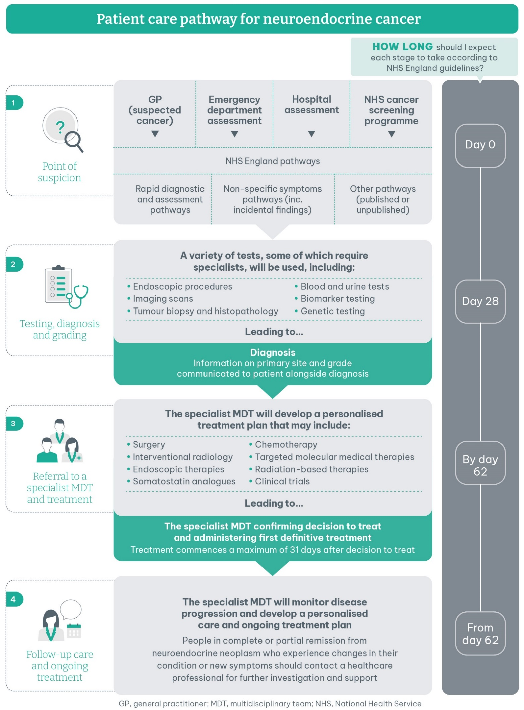
The care pathway was developed by Neuroendocrine Cancer UK and The Health Policy Partnership in collaboration with patients, patient advocates, clinicians and industry representatives. If you have any questions about the pathway, please contact: campaigns@ncuk.com

